**Name:** Atharva Salitri

**Year & Branch:** TY-CSAI-B

**Batch:** 2

**Roll no:** 29

**PRN:** 12310120

**Subject:** Cloud Computing

Assignment 02

**Title:** Creating account with AWS and launching EC2 instance

**Amazon EC2 Overview**

**Amazon EC2 (Elastic Compute Cloud)** is a web service by Amazon Web Services (AWS) that provides scalable virtual servers in the cloud. It enables users to deploy and manage virtual machines, known as instances, to run applications with flexibility and efficiency. With EC2, you can quickly scale your computing capacity up or down based on your needs, making it ideal for a wide range of use cases, including web hosting, software development, and data processing.

**Launching an EC2 Instance**

To launch an EC2 instance, follow these steps:

1. **Sign In to AWS Management Console**: Navigate to the [AWS Management Console](https://aws.amazon.com/console/).
2. **Open EC2 Dashboard**: Go to the EC2 service under "Compute" in the AWS Management Console.
3. **Launch Instance**:
   * Click on the "Launch Instance" button.
   * Choose an Amazon Machine Image (AMI).
   * Select an Instance Type based on your needs.
   * Configure Instance Details like number of instances, network settings, etc.
   * Add Storage if needed.
   * Add Tags to organize your instances.
   * Configure Security Group settings for firewall rules.
   * Review and launch the instance.
4. **Select or Create a Key Pair**: Choose an existing key pair or create a new one for SSH access to your instance.
5. **Launch**: Click the "Launch" button to start the instance.
6. **Select or Create a Key Pair**: Choose an existing key pair or create a new one for SSH access to your instance.
7. **Launch**: Click the "Launch" button to start the instance.

Below is the explanation with Screen Shoots:

**Step 1. Select a region**

One of the most important steps is to select the desired AWS region. This can be done from the top navigation bar of the AWS Console

**Step 2. Navigate to the EC2 Console**

Once you select the desired AWS region, go to the EC2 Console. From the same landing page, search for EC2. Your landing page in the management interface will likely display EC2 among the most commonly used services in the account.

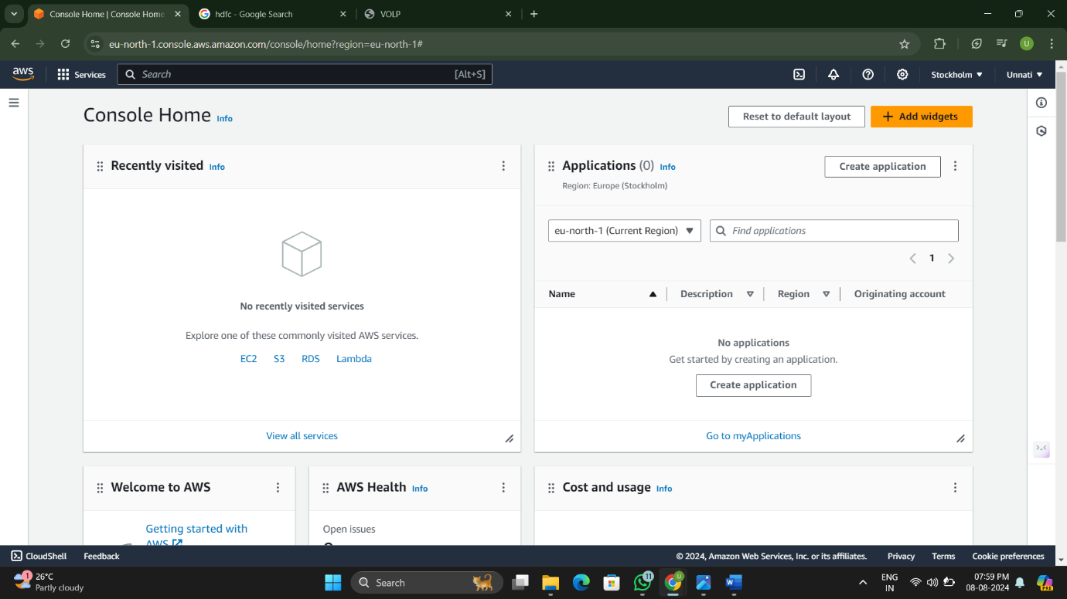

**Step 3: Launch Instance**  
In the EC2 console, click on the “Launch Instance” button to start the instance creation process. This will take you through a series of steps to configure your instance.  
After clicking on the “Launch Instance” button, you will be redirected to a page as shown below.

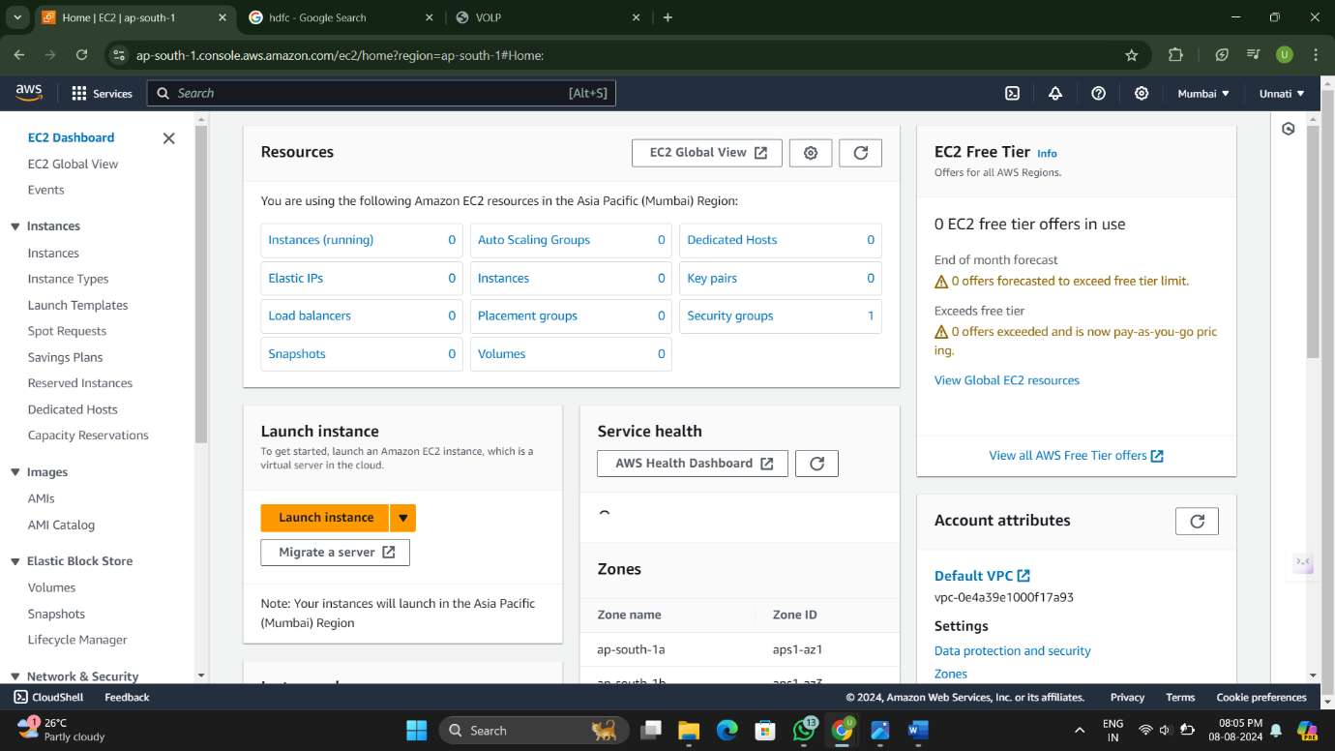

**Step 4: Provide a Name for the EC2 Instance**  
You need to provide a name for your EC2 instance. Giving your instance a meaningful name can help with easy identification and management of your resources in the future.

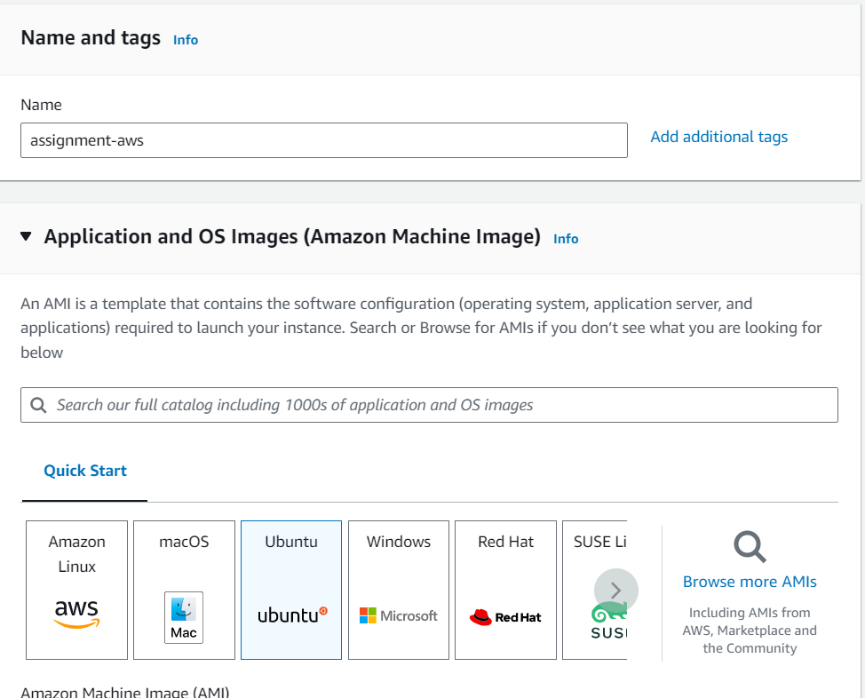

**Step 5: Choose an Amazon Machine Image (AMI)**  
An Amazon Machine Image (AMI) is a pre-configured template that contains the operating system and other software necessary for your instance. In this step, you can choose from a wide variety of AMIs provided by AWS or the AWS Marketplace. Select an AMI that best suits your requirements.  
In this case, you can choose “Amazon Linux” as the operating system for your instance.

**Step 6: Choose an Instance Type**  
The instance type determines the hardware of the host computer used for your instance. AWS offers a range of Instance Type with varying compute, memory, and storage capabilities. Consider your workload requirements and select the instance type that meets your needs.  
In this case, you can select “t2.micro” as the instance type. The “t2.micro” instance type is eligible for the AWS free tier, which provides limited free usage of certain AWS services.

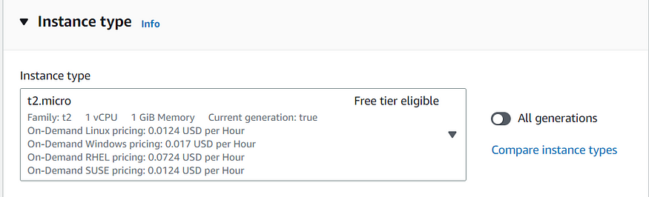

**Step 7: Create a Key Pair**To securely access your EC2 instance from your system, you need to create a key pair. A key pair consists of a public key that AWS stores and a private key that you download to your local machine. The private key is used to authenticate and establish a secure connection with your EC2 instance.

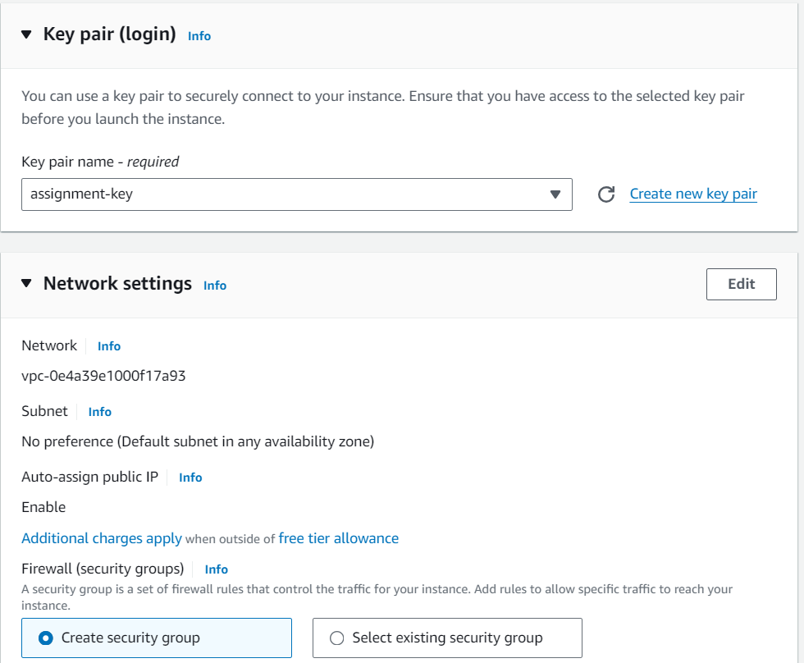

Upon clicking this button, a dialogue box will appear where you can provide a unique name for your key pair. Select the key pair type as “RSA” and choose the private key file format as “.pem”.  
Finally, click on the “Create Key Pair” button to generate your new key pair.

**Step 8: Configure Instance Details, Add Storage, and Configure Security Groups**In this step, you can configure various settings for your EC2 instance. Adjust these settings based on your specific requirements. You have the flexibility to update these details even after launching the instance.

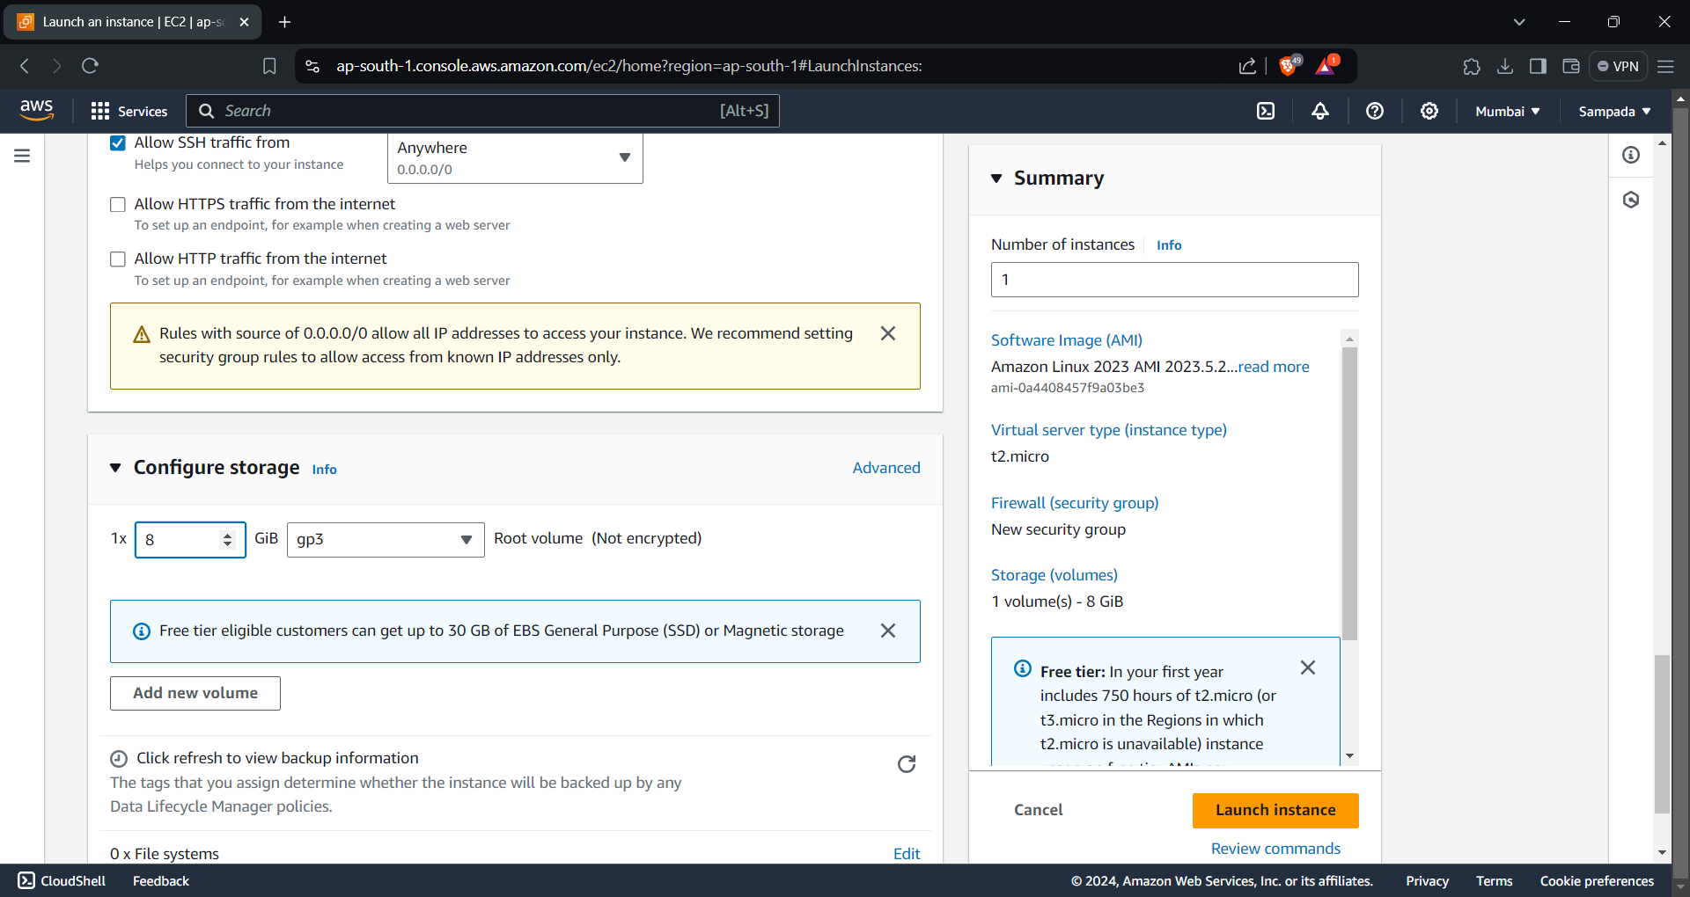

**Step 9: Review and Launch**  
Before launching the instance, review the configuration details to ensure everything is set up correctly. Double-check the instance type, storage options, security groups, and any additional settings you have configured. If everything looks good, click on the “Launch Instance” button.

